**Media 1- Winehouse-0, once again the media won an inequitable battle**

**Daisy Mason**

Her death was shocking, but unfortunately all too predictable, through dramatized stories and unflattering photos not only was her public appearance damaged, but also her confidence and drive to keep fighting. First it was her bulimia, then it was alcohol and then finally drugs, how many more variables are the media going to chuck in to blame her death for? It’s funny really, because not once have they even considered that they might, just maybe, have been the reoccurring problem which led to her decline.

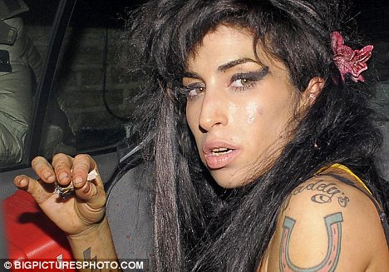

Her career started in 2003 when her first album, Frank, received attention through the public eye, describing her voice as “distinctive” and “smoky”. However, albeit well and good that her career was starting to accelerate, things soon took a turn in her personal life, and she became a broken, confused young lady who was in the grip of a monster, provoked by her ex-boyfriend

Blake Fiedler, she could not shake loose. The media had recognized her addiction was worsening and, after her award-winning Back to Black album, loved the vulnerability within it. The abundance of appraisal was short-lived and, rather ironically, her lead song “rehab”, received mounds of attention- not because of her unique voice, but due to her personal struggle with addiction and drugs.

Gaining 3 Grammy’s gave her plenty of attention, but it was the relationship with alcohol and drugs which received the most scrutiny and lead to her being made the poster girl for Britain’s broken youth. Her addictions inevitably lead to the decline of her performances and the high, disorientated and dissociative star therefore became exploited by the press over the decline of her lacklustre shows.

Winehouse was also no stranger to the police and, after her alleged headbutting ‘fix’ towards a man, while out on a night out, she was bombarded with scrutiny from several newspapers, particularly The Daily Mail. Their leading headline was “Wild Amy Winehouse facing arrest after 'attack on TWO men' while out on drug-fuelled bender”, noticing how they use the word “wild” to describe the star and “drug-fuelled” to describe her activities. Derogatory terms such as these automatically give the public a reason to impose hate on Winehouse and hence, lead her to have later fallen into the 27 club.

No one implicitly understood the task of respecting her privacy and that’s why it’s hard to deny that her struggles were made infinitely worse due to her public arena. She was the talk of society and her fame and loss of privacy therefore landed her with the amplification of her personal issues. “Crack whore”, “drunk-ass bigot” and “white trash” are just a handful of the comments made and, photos like the one above, fuel the negative representation of her.

Amy was ready to throw it all away. “If I could give it back, just to walk down that street with no hassle, I would” (comment made a few weeks before her death)- but by then, it was too late. Unfortunately, it was too late and the ravenous creatures that had surrounded her for a while, gradually picked away at her little by little.

.