**Public discourse surrounding the influences of make-up brands on pre-adolescents.**

**Introduction**

In recent years, the public discourse surrounding the influences of skincare brands on teenagers has gained a considerable amount of attention and scrutiny. As society continues to become increasingly immersed in consumer culture and digital media, beauty brands have a significant amount of influence over the attitudes, behaviours, and self-perceptions of pre-adolescents. From promoting unrealistic beauty ideals to purchasing decisions, brands play a huge role in the lives of teens, sparking discussions about beauty standards, consumerism, and societal values. I aim to foster a more nuanced understanding of beauty, promote healthier attitudes towards self-care, and advocate for greater transparency and accountability in the beauty industry.

**Literature Reviews**

The discourse surrounding the influences of brands on teenagers is a complex combination of societal, cultural, and psychological dynamics. This comprehensive literature review aims to delve into this phenomenon by integrating influential theoretical frameworks which, in turn, will enable me to delve further into this subject and analyse in greater depth, with more reliability.

Advertising shapes beauty standards, impacting individuals' perceptions of attractiveness and hence, brings about the ideology of social comparison. Beauty brands, in particular, utilize advertising to promote specific beauty ideals and so, this section intends to explore how their ads contribute to issues surrounding, social comparison, objectification and self-esteem, particularly among pre- adolescents. Social comparison theory (Festinger, 1954) proposes that individuals determine their own social and personal worth based on how they stack up against others and has been used within works of academics- Martin and Kennedy’s “Advertising and Social Comparison: Consequences for Female Preadolescents” in particular (Martin & Kennedy, 1993). Based on this theoretical framework, they carried out empirical research consisting of data collection, surveys, and interviews, to examine the impact of advertising and social comparison on female preadolescents and concluded that girls who engage in these activities, experience a higher level of self- dissatisfaction and lower self-esteem. Their quantitative analysis enabled them to allow for statistical examination of relationships and patterns which hence, enabled them to form a strong and reliable analysis. Despite this being an incredibly valuable piece of literature which I strongly intend to use as the basis of my project, there could have been a deeper content analysis- which advertisements are more influential? Because of this, the aim is to build upon their research by incorporating advertising materials to further uncover patterns and trends in how beauty ideals are portrayed.

Similar to this, albeit using a quantitative research method, is Fredrickson and Roberts’ work on Objectification Theory (Fredrickson and Roberts’, 1997). Their theory hosts the ideology that girls and women are typically inclined to internalize societal messages which, in turn, leads them to view themselves through an external observer’s perspective. From this, they highlight how objectification contributes to body dissatisfaction and diminished self-esteem, with their analysis ultimately underscoring the potential harmful effects of beauty brands’ marketing strategies that promote unrealistic beauty standards. Although this can be used as theoretical research to elevate part of my analysis, I believe this is slightly beyond the scope of my project and perhaps not fully relevant to the aspects I’m wanting to investigate.

However, social comparison is merely just one element of the hegemonic narrative brands project onto society and so, to gain a deeper insight into an alternative consequence such as educational priorities, Juliet B. Schor provides an excellent analysis on consumer capitalism in her literature “Consumer Culture and Gender” (Schor, 1994). Published in 1994, Schor's study remains a foundational text in the field of cultural studies, providing theoretical and empirical insights into how consumer capitalism shapes individuals' identities and behaviours. In terms of her literature, the focus on gender may be tangential and so, a limitation is present, but despite this, she puts key emphasis on the role of advertising, marketing, and consumption practices in shaping societal norms and values and so, view it as imperative to be present within my discussion. Both her theory based and experimental methods allow for greater reliability and usage within my analysis and with the aim of analysing advertisements deeper, this discussion aims to build upon her works.

This review sets the stage for deeper analysis of advertising and its impact on pre-adolescent well-being, emphasizing the need for further research and critical engagement with societal values.

**Methods**

For this analysis to take place, 5 make up advertisements were collated, coarsely analysing the lexis and pragmatics used. In turn, public discourse was then evaluated through obtaining sufficient evidence from several social media platforms and chat forums in order to gain perspectives and opinions surrounding the issue at hand.

Integrating these two methods will allow me to build upon previous literature and provide greater intellect for readers surrounding this subject field.

**Analysis**

To complete a full analysis, it was important to categorize my research into three categories; self-esteem, objectification and education and so, to test for the extent to which these are effected I targeted 2 major brands popular among teens ( Benefit and Rimmel ) and proceeded to gather sufficient evidence through media platforms to provide an understanding about the discourse surrounding the issue.

**Education and priorities**

As we are aware, education lies at the crux of adolescent’s priorities and so, seeking out the extent to which this is inevitably affected by make-up brands was of top priority. To complete this part of my analysis, I found two advertisements from Benefit Cosmetics and Rimmel which put coarse emphasis on the superiority make up holds over education, the sources state “ Skip Class not concealer!” and “ Get ready to slay this back to school season!”, both of which clearly aim to target a younger audience knowing they’re more susceptible to not only consumerism but also obsession, addiction and vulnerability. To seek the public opinion on this and correlate the evidence with the research question at hand, two platforms were analysed; Mumsnet and Twitter, both of which had negative attitudes towards each advertisement, displaying a common pattern of the view that the hegemonic society we live in subtly convinces young girls the primary value is deemed to lie within their looks, abstaining drawing any importance towards education. One advocate expressed her concern on the matter by stating ads like these “encourage teens need to “slay” to be successful", whilst a mother raised her concerns, by stating her child already stands as “a victim to pressure of education”, so enforcing the need to prioritize perfection over education is further anxiety and stress.

**Self-esteem and objectification in advertising**

Perhaps one of the most crucial elements to focus on is the persistent pressure young people are succumbed to with regards to beauty ideals- self-esteem, body dissatisfaction and objectification being at the forefront. In 2014, Benefit emerged with a new mascara, with the slogan “They’re real, honest ”, placed next to a women flaunting her enlarged breasts holding the new product. The brand is incredibly popular with younger audiences but putting an image of a clearly photoshopped woman with flawless skin and the idealized body, is inevitably going to cause comparison and competition among this age bracket and stimulate thoughts of insecurities. Once again, public discourse was majorly negative, evidence to support this was found from Mumsnet, a public forum, where people state it’s “undermining women” and a “classic example of sexual objectification, reducing women to the sum of their body parts”. The discourse continues as Benefit proceeded to launch a new foundation, stating “Goodbye imperfections, Hello Flawless”, placed next to society’s “ideal” , flawless woman, eliciting the idea that hyperpigmentation, redness and spots should be discouraged. The public opinion proceeds to stress the unrealistic expectations portrayed in this ad, with members of Instagram stating it’s a “detriment to young people’s mental health and identity as a woman”.

All aspects present within this study have been supported by evidence of negative public discourse and so, it’s inevitably clear that there are issues to be addressed and explained.

**Discussion**

The project represents a systematic enquiry into the public discourse surrounding the influences of beauty brands on adolescents, with respect to self-esteem, health and education. Specifically, this study attempted to determine the extent to which the public are in agreeance with the idea advertisements and attitudes of make up brands have become a negative influence onto society. Cultural Hegemony (Jackson Lear, 1985) is a concept incredibly vital to consider when it comes to this discussion, as it coincides with the idea that beauty brands wield significant influence over teenagers by shaping their perceptions of beauty through advertising and social media, something that can clearly be seen amongst the sources I collated. The brands Benefit and Rimmel are seen to be establishing and perpetuating beauty norms, such as flawless skin, slim bodies, and specific facial features, which in turn leads to teenagers internalizing these standards and aspiring to them which, hence, leads to severe public concern and opinion.

It’s noticed that sexual objectification and self-esteem were the most prominent aspects, with Benefit’s 2014 ‘They’re real, honest’ advertisement gaining the most public dissatisfaction amongst those on Twitter and Mumsnet. The language within the slogan ‘They’re real, honest’ is interpreted as reducing women merely to objects or commodities, something which coincides with Fredrickson and Roberts’ Objectification Theory (Fredrickson & Roberts, 1997), who exert the idea that advertisements like these lead to experiences of objectification and feelings of inadequacy. Similar to this, is Ross Krawczyk and J.Kevin Thompson’s (Krawczyk & Thompson, 2015) research which consists of detailed analysis into how the exposure to such detrimental advertisements influences individuals self-perception and encourages a hegemonic narrative among society- several comments on Twitter were found in agreeance with this ideology, hence supporting this research.

In terms of education, two advertisements were found; Benefit’s ‘Skip Class not concealer’ and Rimmel’s “Get ready to slay this back-to-school season” , both showing features of undermining young women, reinforcing the idea their value lies solely in their adherence to beauty ideals. Juliet Schor’s literature (Schor, 1994) can be used to support this observation, as her analysis demonstrates how consumer culture promotes the notion that women’s worth is determined by their appearance and consumption habits, undermining their agency, in this circumstance being intellectual abilities, and reinforcing gendered hierarchies within society. Consumer Capitalist theory, developed from works of Veblen (Veblen, 1899) can also be used to support this literature, ultimately emphasizing the capitalist nature brands hold to exert consumerism on people, adolescents in this case, as a means of determining social hierarchies. In this specific context, it could be suggested that brands capitalize consumer culture by promoting the idea purchasing make-up products is essential for individual happiness, success, and social acceptance, positioning these elements as superior to education or personal development- all of which were highlighted within the public discourse analysed in public forums and twitter.

**Conclusion**

In recent years, scrutiny over brands' influence on teenagers has intensified as they wield significant influences over adolescent attitudes and behaviours. Beauty brands, in particular, have been under the spotlight for perpetuating unrealistic beauty ideals through their advertisements and social media presence. From promoting flawless skin to emphasizing specific facial features, these brands contribute to a culture of unattainable beauty standards. The analysis has identified there is a constant growing concern about the prioritization of makeup over education in beauty brand marketing strategies and both brands’ advertisements analysed exemplify this trend, raising questions about societal values and priorities. Drawing from consumer culture analysis and theories of capitalism, the study illuminates and underscores the importance of critically engaging with advertising to foster healthier attitudes towards beauty, self-worth and education among adolescents.

**References**

Festinser, L. (1954) A Theory of Social Comparison Processes. Human Relations [online]. 7 (2), pp. 117-140. [Accessed 02 May 2024]

Fredrickson, B.L. and Roberts, T. (1997) Objectification Theory: Toward Understanding Women's Lived Experiences and Mental Health Risks. Psychology of Women Quarterly [online]. 21 (2), pp. 173-206. [Accessed 05 April 2024]

Lears, T.J. (1985) The Concept of Cultural Hegemony: Problems and Possibilities. The American Historical Review [online]. 90 (3), pp. 567-593. [Accessed 09 April 2024].

Martin, M.C. and Kennedy, P.F. (1993) Advertising and Social Comparison: Consequences For Female Preadolescents and Adolescents. Psychology and Marketing [online]. 10 (6), pp. 513-530. [Accessed 18 April 2024].

Schor, J.B. (1994) The Culture of Consumer Capitalism: A Critical Review of the Literature. Gender Studies Quarterly [online]. 20 (3), pp. 317-335. [Accessed 02 May 2024].

Thompson, J.K. and Krawczyk, R. (2015) The Effects of Advertisements That Sexually Objectify Women on State Body Dissatisfaction and Judgments of Women: The Moderating Roles of Gender and Internalization. Body Image [online]. 15, pp. 105-119. [Accessed 02 May 2024].

Veblen, T. (1899) The Theory of the Leisure Class: An Economic Study of Institutions. New York: Macmillan

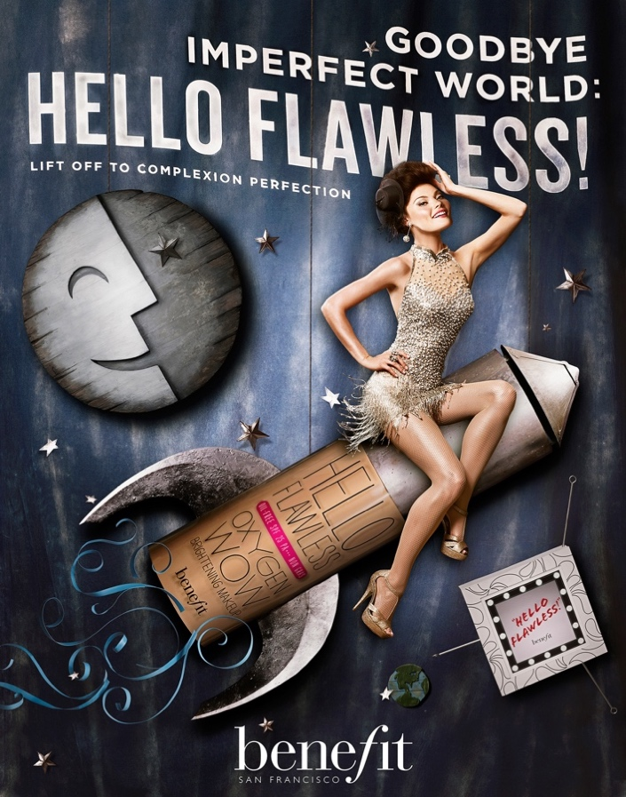

**Appendices**

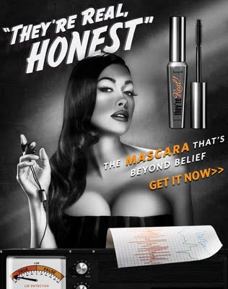

Critique of Unrealistic Standards:

"Ads like these perpetuate harmful beauty standards, telling teens they need to 'slay' to be successful. It's time to embrace diversity and reject these unrealistic expectations." - Maya, body positivity advocate

Concern about Pressure on Teens:

"As a parent, I worry about the pressure ads like this put on my daughter. She's already dealing with so much during back-to-school season, she doesn't need the added stress of feeling like she has to look perfect." - Sarah, mother of a teenage girl

Empowerment Through Self-Expression:

"I love seeing ads that encourage self-expression and confidence. Teens should feel empowered to express themselves however they want, whether that's through makeup or anything else." - Alex, makeup enthusiast

Criticism of Consumerism:

"This ad is just another ploy to get teens to spend money on products they don't need. It's time to stop prioritizing consumerism over young people's well-being." - David, consumer rights advocate

Recognition of Advertising Tactics:

"As a teen myself, I can see right through these advertising tactics. They're trying to manipulate us into thinking we need their products to be cool. But I'm not buying it." - Emily, high school student

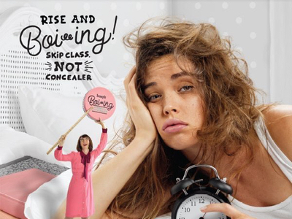

Public discourse: emphasizes the idea that, for women, as long as your pretty education is not an issue.

* Highlights the hegemonic society we live in.
* Ad wants women to conform to male dominated society.
* Beauty not brains- can’t be pretty and intelligent.
* Encouraging young people to invest in expensive products which, not only encourages them to feel the need to improve their appearance, but also encourage excessive consumption of products at such an early age.

Article quotes:

**Cosmetics business:**

“Women across the globe are battling to receive an education @Benefit are telling them ‘skip class not concealer’ something doesn’t add up”

**Daily Mail July 2017 – Siofra Brennan for MailOnline**

Josh Key (teacher) claims it tells girls they ‘just need to be pretty’.

**Echo 2017**

Labour MP for Rotherham and Shadow Secretary of State for Women and Equalities, Sarah Chamption slammed the campaign for “encouraging girls to value make-up over education”.